Joe Merrill 09MAR21
CMSC350 Project 4

UML Class Diagram

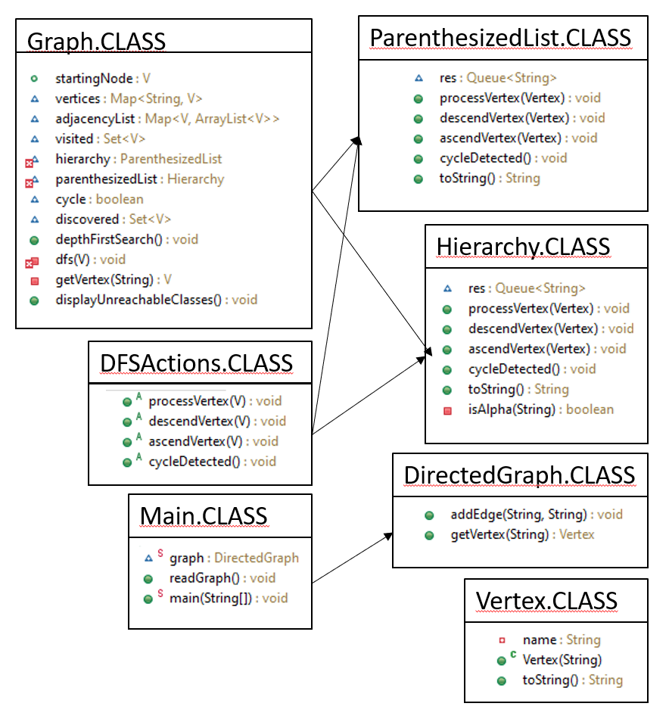

# | Input | Expected Output | Actual Output | Pass?
1 | ClassA ClassC ClassE ClassJ  ClassB ClassD ClassG  ClassC ClassA  ClassE ClassB ClassF ClassH  ClassJ ClassB  ClassI ClassC | ClassA  ClassC  ClassE  ClassB  ClassD  ClassG  ClassF  ClassH  ClassJ  ClassB  ClassD  ClassG | 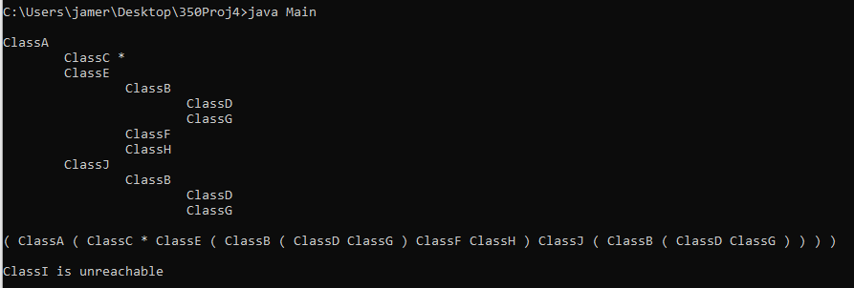 | YES  (Expected Output was wrong)
2 | ClassA ClassB ClassC ClassD  ClassB ClassE ClassF  ClassC ClassG  ClassD ClassH ClassI ClassJ  ClassE ClassK  ClassG ClassL | ClassA  ClassB  ClassE  ClassK  ClassF  ClassC  ClassG  ClassL  ClassD  ClassH  ClassI  ClassJ | 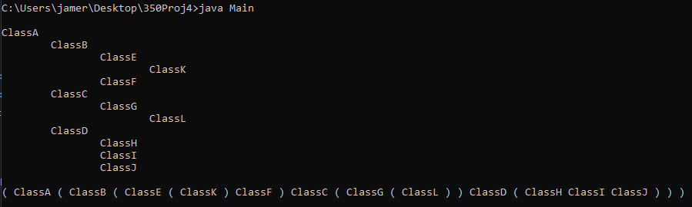 | YES
3 | ClassA ClassF ClassC  ClassB ClassG ClassF  ClassC ClassI  ClassD ClassJ  ClassE ClassK | ClassA  ClassF  ClassC  ClassI  ClassB is unreachable  ClassG is unreachable  ClassE is unreachable  ClassK is unreachable  ClassD is unreachable  ClassJ is unreachable | 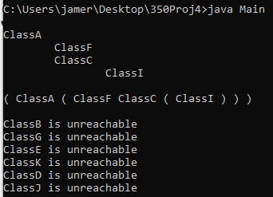 | YES

This final project, although tough for me, is one of the more useful Java projects I have completed. This can be used for creating outlines of categories and sub-categories from a simple text file.

